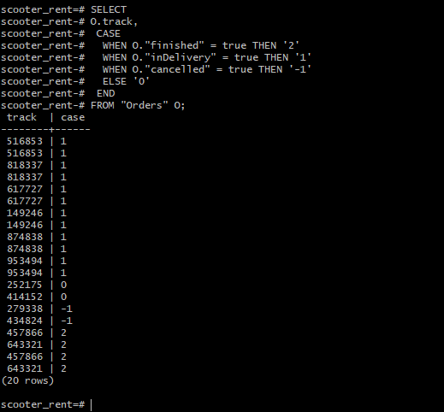

*SELECT*

*O.track,*

*CASE*

*WHEN O."finished" = true THEN '2'*

*WHEN O."inDelivery" = true THEN '1'*

*WHEN O."cancelled" = true THEN '-1'*

*ELSE '0'*

*END*

*FROM "Orders" O;*